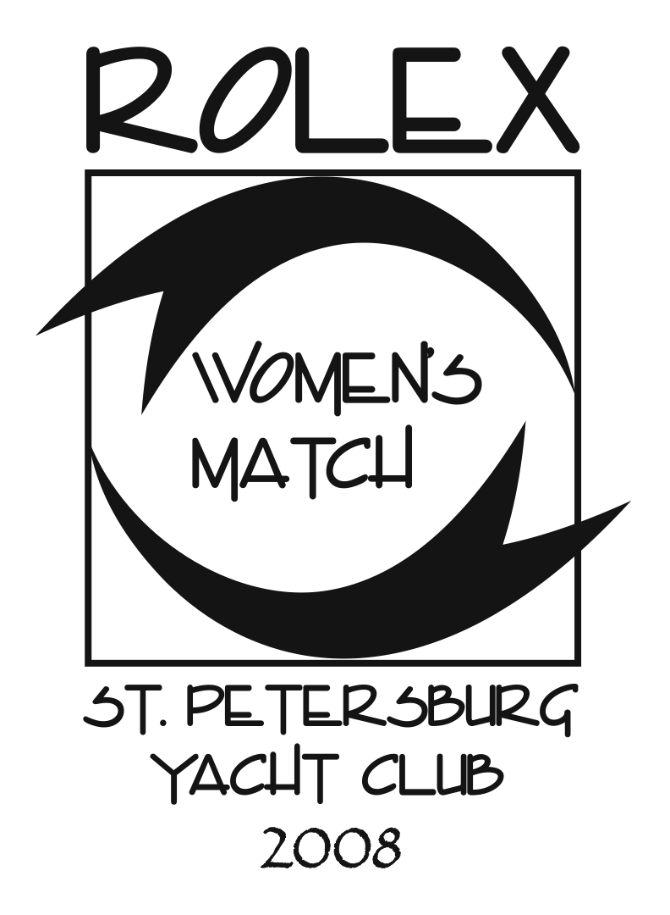
Rolex Women’s Match set for April 10-13 in St Petersburg, Fla.
Format change to focus on round-robin matches; SPYC to develop umpire skills

St. Petersburg, Fla. (February 5, 2008) – St. Petersburg Yacht Club (St. Petersburg, Fla.) has announced a change in format to its popular Rolex Women’s Match, an International Sailing Federation (ISAF) grade 3 match racing regatta, scheduled for April 10-13, 2008. Created in 2002 to introduce women sailors to one-on-one match racing with skills clinics and practical on-the-water experience, the event will now consist solely of round-robin match racing.

“With the increased in interest in women’s match racing around the world, specifically for inclusion at the 2012 Olympic Games, we felt our initial mission of getting more women sailors into match racing has been accomplished,” said Pat Seidenspinner the co-chair of the event with Tom Farquhar. “Now our focus is to run as many matches as we can over the four days. Additionally, we will be giving prospective match racing umpires an opportunity to hone their skills and knowledge when we host an umpires seminar immediately prior to the Rolex Women’s Match.”

Raced on Tampa Bay in Sonar class keelboats, Seidenspinner and her race management team will organize up to 90 matches with the winning skipper and runner-up gaining an automatic invitation to SPYC’s Rolex Osprey Cup, an ISAF grade 1 match racing regatta, schedule for October 22-25.

The list of skippers who have accepted an invitation includes: Louise Bienvenue (Metarie, LA), JoAnn Fisher (Annapolis, MD), Corey Hall (St. Petersburg), Sandy Hayes (Scituate, MA), Liz Hjorth (Marina del Rey, CA), Lauren Knoles (East Lansing, MI). Katy Lovell (New Orleans, LA), Sue McDowell (Bay Village, OH), Rossana Ramos (Brasilia, Brazil) and Rachael Silverstein (St. Petersburg).

“In the past six years we have noticed a steady increase in the number of women sailors who now are proficient at match racing,” said Seidenspinner. “Now that there is a greater demand for match racing events in the U.S., we want to encourage other yacht clubs to run them so that all of the women sailors can get a chance to try the exciting duel on the water that is match racing.”

To further that goal, SPYC will host an US SAILING umpire seminar on April 9. Presented by Steve Wrigley, an international umpire, international judge and a member of the US SAILING umpire committee, the seminar is designed to train prospective umpires in the skills they will need to become an umpire, and to provide continuing education for certified US SAILING umpires. The one-day program will utilize video and computer models to develop proper umpire communications and the anticipation skills necessary to be successful as an umpire. For more information, contact Wrigley at email: wrigs@earthlink.net.

For more information about Rolex Women’s Match, please visit the St. Petersburg Yacht Club website www.spyc.org and the Rolex Women's Match website www.rolexwomensmatch.org.

About Rolex Watch U.S.A.
Since Rolex Watch U.S.A. first presented timepieces to America’s Cup defenders in 1958, the company has consistently recognized and encouraged excellence in every important arena of competitive sailing, including elite athlete preparation, US SAILING championships, disabled sailing, and offshore, one-design and women’s events.

The Rolex Women's Match joins other prestigious Rolex-sponsored events including the Maxi Yacht Rolex Cup, Rolex Fastnet Race, Rolex Farr 40 World Championship, Rolex Big Boat Series and the Rolex Sydney Hobart Yacht Race.

(end)

